Market analysis:

Indirect competitor: (instrumentation amps)

* Texas Instruments
* Analog Devices
* Microchip Technology Inc
* Renesas
* STMicroelectronics
* Kyowa
* TMD
* QuinStar Technology

Instrumentation Amplifiers Market Segment by Types, covers:

* Two-op-amp Instrumentation Amplifier
* Three-op-amp Instrumentation Amplifier
* Others

Instrumentation Amplifiers Market Segment by Applications, can be divided into:

* Steel and Cement Industry
* Food Industry
* Pharmaceutical Industry
* Chemical Industry
* Others

\* The popularity of ASICs is increasing. Surprised? Then consider (1) all the hardware products around you use chips and (2) yes, software may be conquering the world but all the software in the world is running on chips. Just have a look at the numbers yourself. The semiconductor industry is booming and set to increase. Companies are producing more silicon and more ASICs will be rolling out to the market every year.

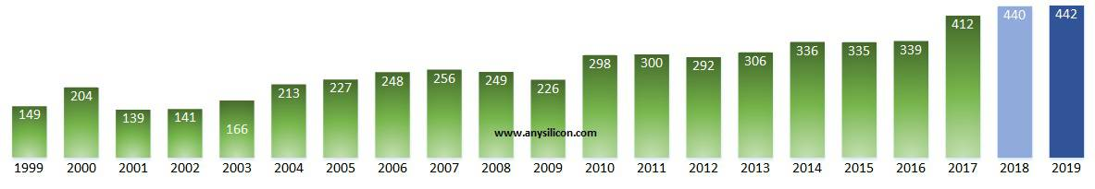

Fig: TSMC Profit chart

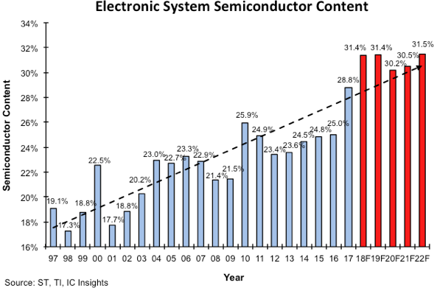

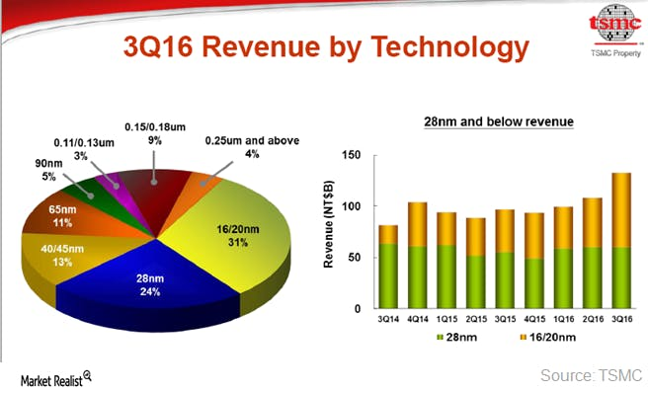

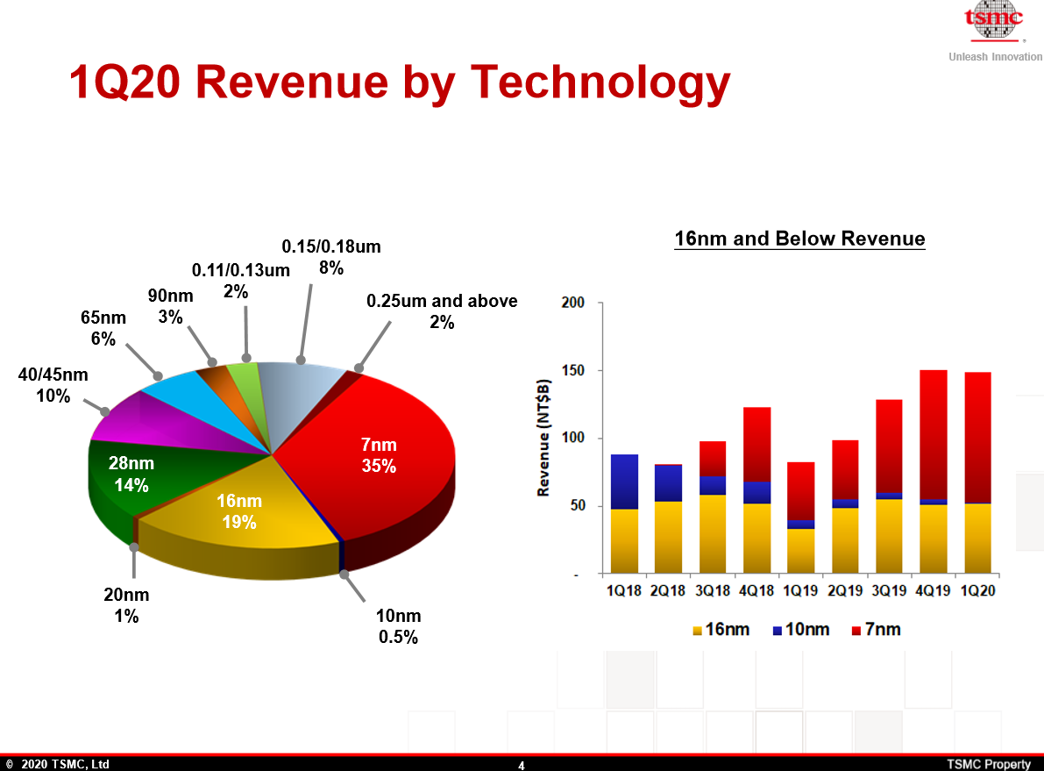

More information :

<https://www.marketwatch.com/press-release/application-specific-integrated-circuit-asic-market-2019--aiming-on-regional-market-conditions-competitors-product-price-profit-capacity-production-and-future-forecast-to-2025-2019-10-17\>

<https://www.alliedmarketresearch.com/press-release/asic-chip-market.html>

<https://www.thebusinessplanshop.com/blog/en/entry/market_analysis_for_business_plan>

<https://articles.bplans.com/how-to-write-a-market-analysis/>

<https://anysilicon.com/ridiculously-smart-guide-developing-asic/>

<https://redirect1.bbportal.bsnl.co.in/portal/?webincws=true&Brand=Brand1&MVNO=1&Partner=DEFAULTPARTNER&UserAgent.Type=Laptop&loc=BGL&status=dailyFupPlan>

<https://www.semiconductors.org/data-resources/market-data/>

<https://www.express-journal.com/request-sample/39844?utm=PC> ->should we try this?